Matthew Meehan

Design and Build of and Loudspeaker

**Introduction:**

At first I had mixed thoughts about designing and building a loudspeaker after a failed attempt of homework 2, but I had noticed that I am capable of trying my best to design and build my loudspeaker no matter what. This lab was outlined to teach us how to design a loudspeaker using an amplifier board, full range driver, a tweeter, a power supply, and cardboard. The design of the loudspeaker was to the best of my ability and understanding, which can be seen in Fig. 1-3. I only hope to have calculated my Thiele-Small parameters correctly as well as any other calculations necessary. Due to the lack of instructions, I completed the lab with an open perspective to as what is going to be concluded as well as to what is going to be looked at. I hypothesize that the loudspeaker I design will amplify the sound inputted by at least double. Overall, I hope to make the correct calculations and to see conclusive results in my lab.

**Procedure:**

* Gather equipment needed to design and build the loudspeaker. This includes: a full range driver, a tweeter, a power supply, stuffing for the box, ply cardboard, a class d amplifier board, 3.5mm 3 conductor aux cord, solder, a microphone, adhesive glue, and wire. It may also have more tools to use for smaller mechanisms of your loudspeaker, as discussed later in the lab.
* Next is to design your loud speaker with calculations of the Thiele-small parameters. The calculations for the parameters can be seen in Figs. 1-3.

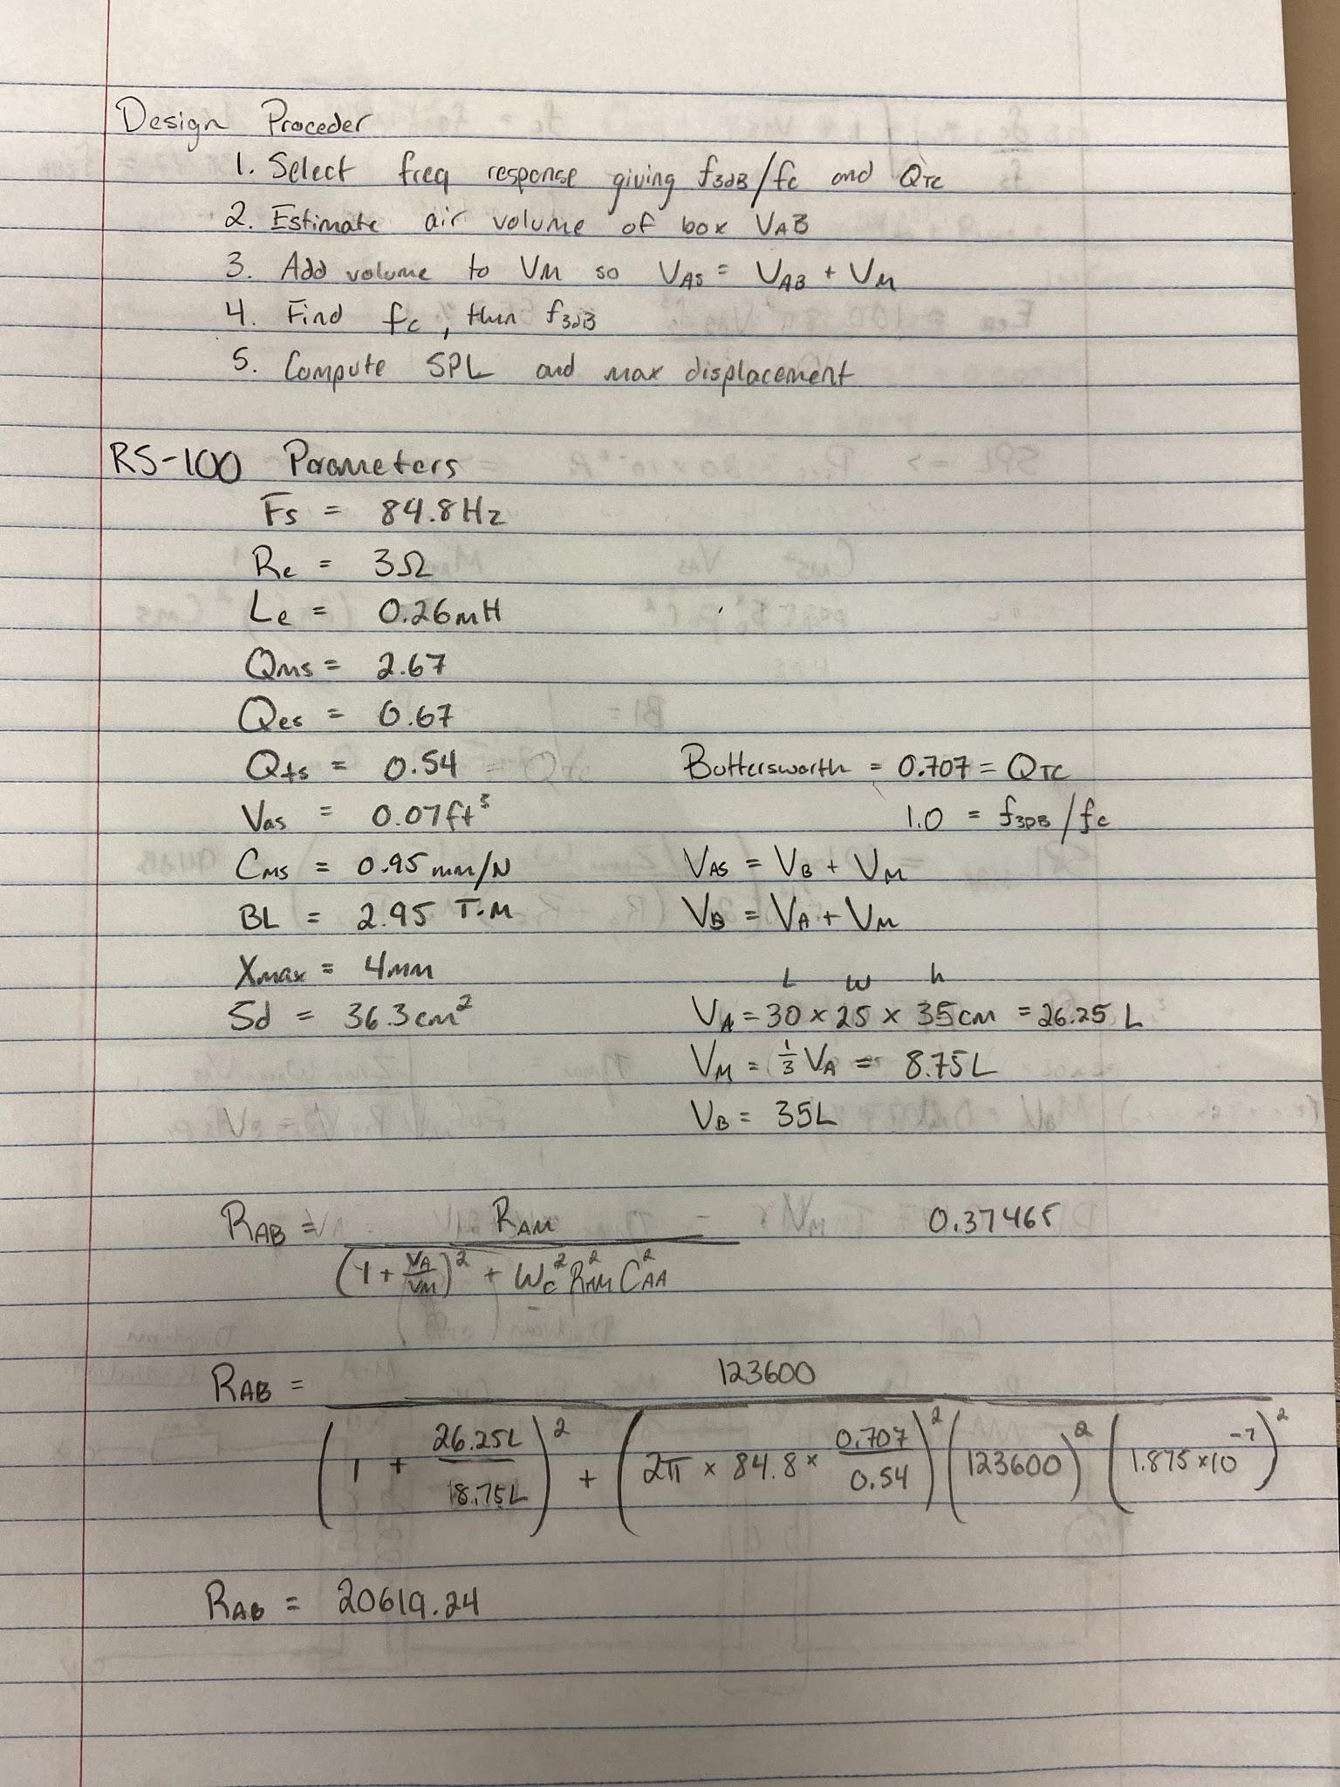

**Fig 1. RS-100 Parameters with box volume of 26.25L design**

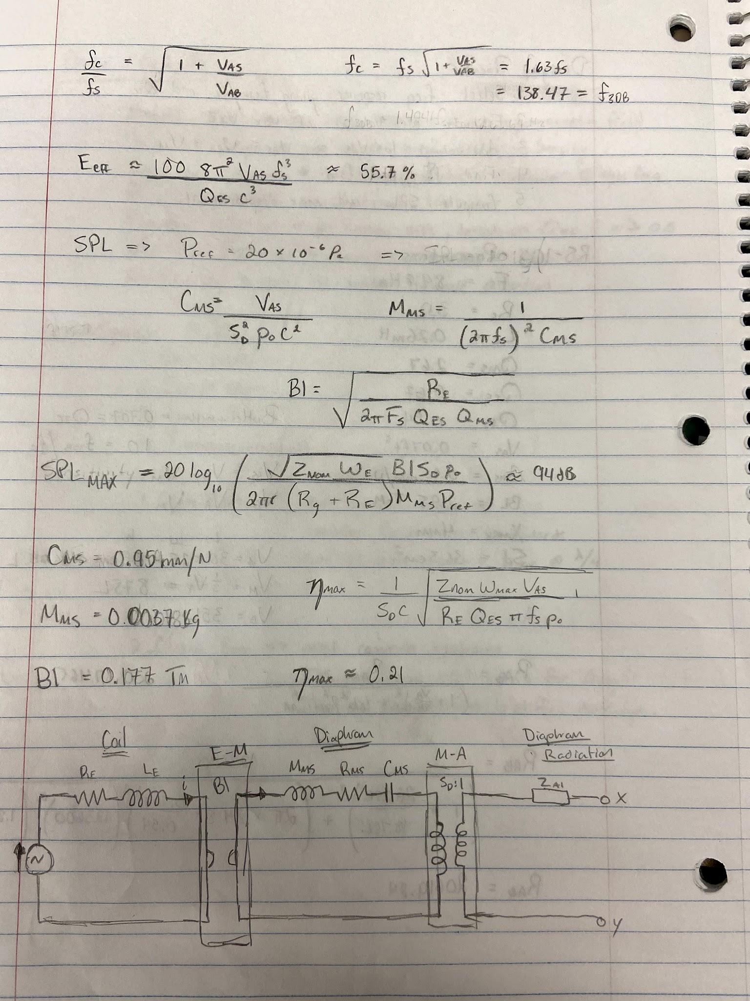

**Fig 2. More calculations and design of circuit**

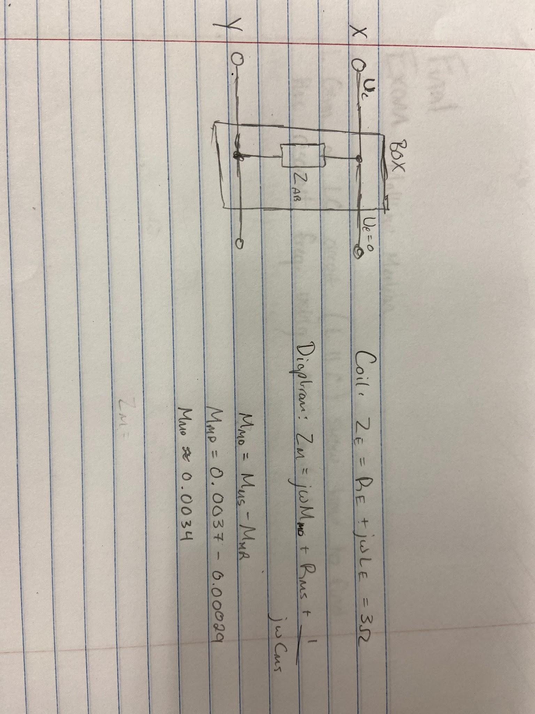

**Fig. 3 Ending of calculations**

* Once you have calculations of the circuit, start your design of the box. Choose dimensions of any size or of 25cm x 30cm x 35cm. Use an exacto knife or box cutter to cut out the dimensions of your box. Make sure to remember that the cardboard has thickness, so incorporate that into the design of the box.
* Next use adhesive to make your box, and be sure to leave the back of the box not glued to the rest of the pieces, for you want it to be removable. Avoid doing this inside if you have a spray adhesive and make sure to correctly get your 90 degree angles.
* The next part of the lab is to solder the wire onto the positive and negative sides of the full range driver and the tweeter. This will allow you to screw in the opposite sides of the wire into the class d amplifier board at the two output ports. Be careful when using the soldering iron.
* Connect the 3.5mm 3 conductor aux cable to the channel 1 and channel 2 inputs of the class d amplifier board. This will allow you to plug in electronics to amplify its sound. You can see all connections to amplifier board in Fig. 4.

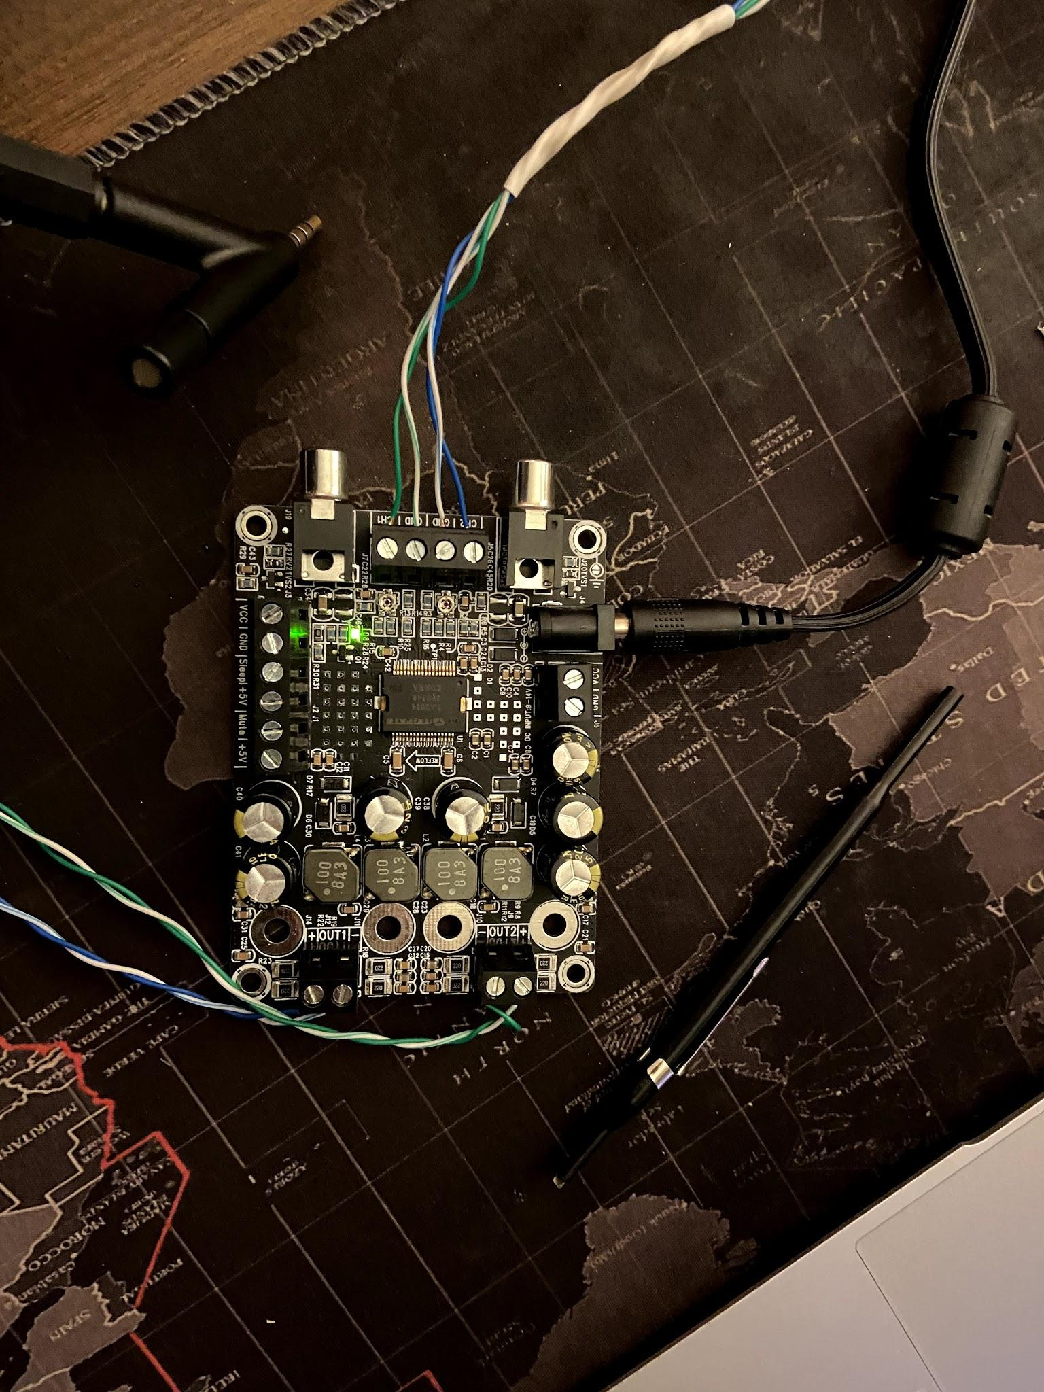

**Fig 4. Connections to amplifier board (3.5mm aux on left, tweeter bottom right, full range driver top right)**

* Once your box is built with 5 sides attached, create a mechanism to allow you to open and close the back of your box. An example is shown in Fig. 5.

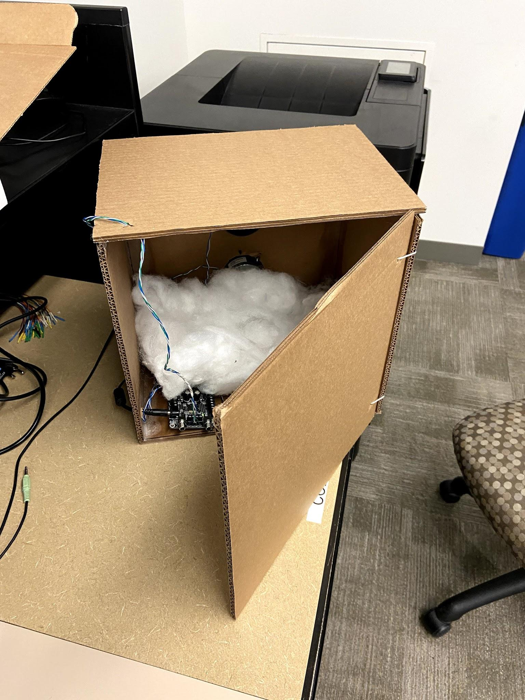

**Fig 5. Opening-Closing mechanism of the box**

* Next cut two holes in the front of the box to allow the insertion of the full range driver and the tweeter. It should look something like Fig. 5. Make sure to cut the holes just right, and do not forget to screw the driver and tweeter into the cardboard after they are in the holes.

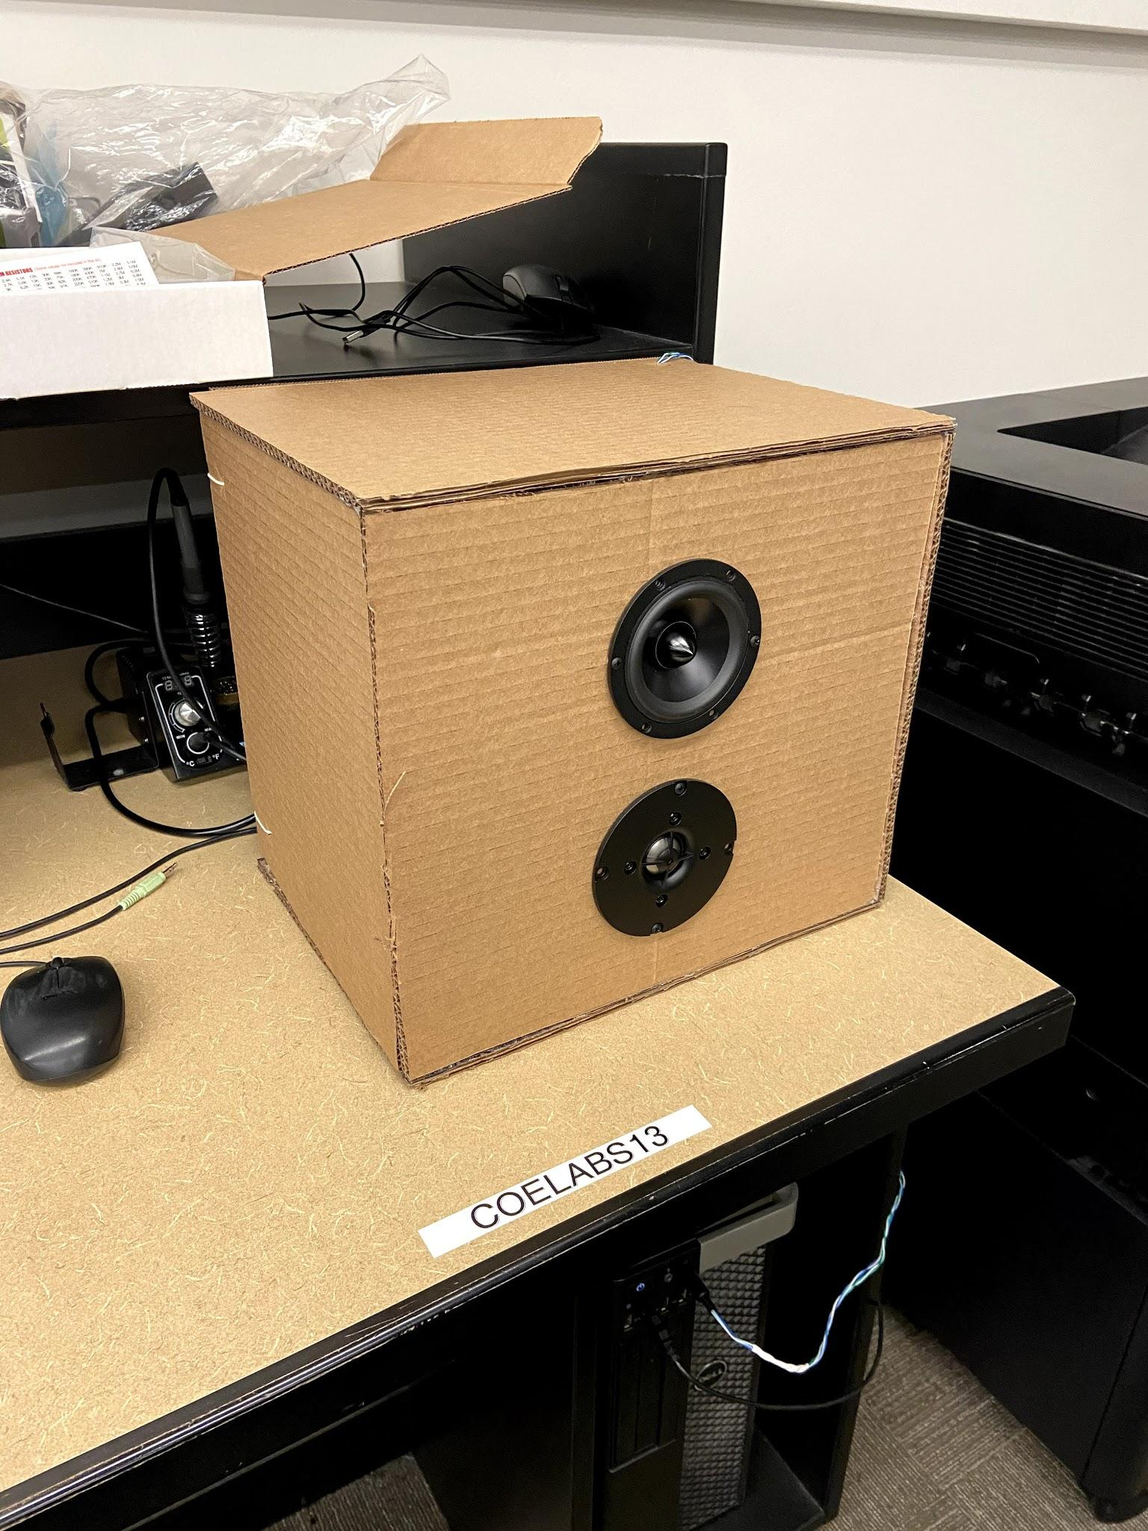

**Fig 7. The front of the loudspeaker**

* Next insert the stuffing into the speaker and do not be afraid to spread the stuffing around.
* The speaker at this point should be built with the power cord and aux inside the box. Create small holes in the sides of the box to allow the power cord and aux to run outside the speaker for easy accessibility for users.

**Results:**

In the testing phase of the loudspeaker make sure that you are using a microphone capable of working correctly. Sadly when using my microphone, I did not receive any input, which may have been a broken/faulty component in my lab, but this was critical to testing frequencies for the loudspeaker.

The simulation in SPICE was something unknown in my range of knowledge, for I have never worked with SPICE before. I made attempts to simulate the loudspeaker using the circuit shown in Fig. 2 and Fig 3 but made no successful efforts in recording the data necessary. However, I did find a simulation method for loudspeakers using ajdesigner. The result of the output vs the frequency of the sound is shown in Fig. 8 and shows 3 different design methods.

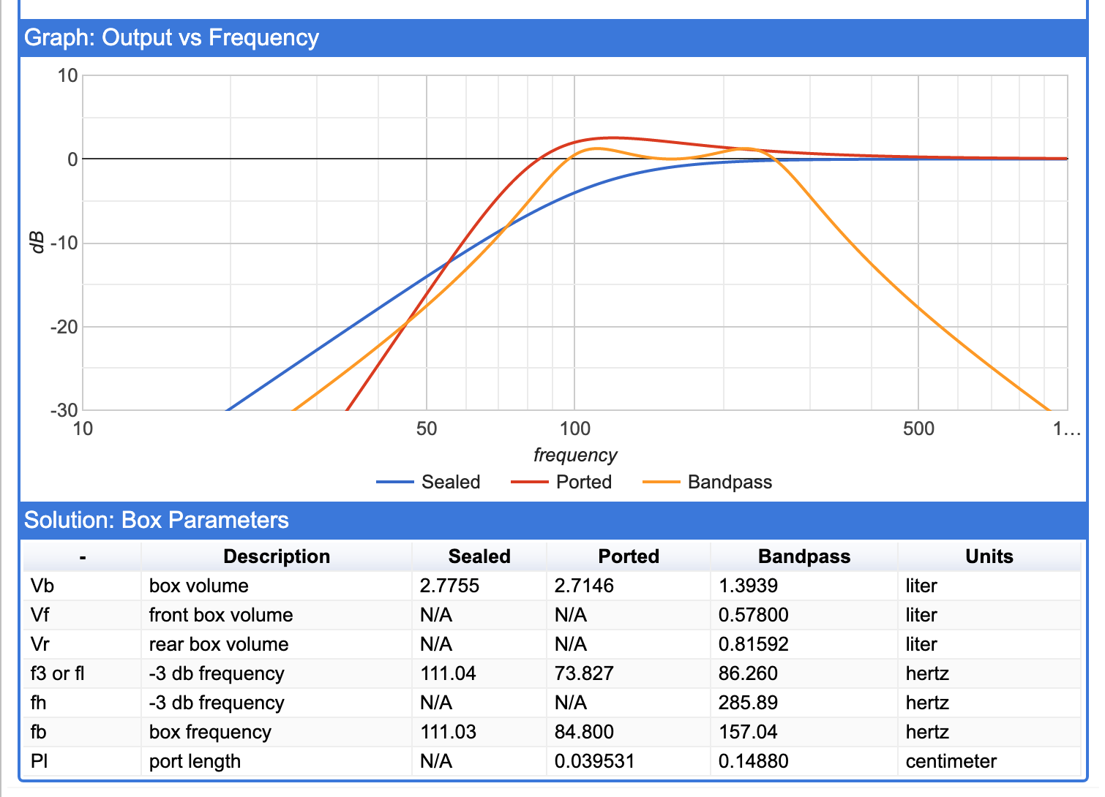

**Fig 8. Output vs Frequency**

When it comes to amplifying sounds it works wonders. I initially tested this with my Nintendo Switch, which amplified the sounds of the games being played, and when moved to the laboratory, I could connect it to the computer and configure it as the speaker of the pc. The produced sounds were fantastically loud as predicted. The attached .MOV file demonstrates the frequencies at which the full range driver and tweeter produce the loudest sounds. I also tested the loudspeaker with American Boy by Estelle ft. Kanye, which is also attached as a .MOV file. Lastly, I tested it with a lightning-aux converter to test my phone's input, which ultimately worked. In all, the results seen are proof of the amplification working which successfully concludes my hypothesis as correct.

**Conclusion:**

While finishing the loudspeaker I concluded that the design was a success, because I had successfully built a loudspeaker that amplified an input signal. Eventhough I was unable to measure the dB gain and frequencies of those dB gains, I knew from my testing of the frequency video that at certain frequencies the amplitude of decibels were various. At lower frequencies the dB gain was much lower than that of higher frequencies. This was a conclusion that I came to at the end of my testing. The loudspeaker was overall a successful build and I enjoyed the time I spent building and designing the speaker itself. Thank you for the opportunity to have hands on experience in building a loudspeaker during online lectures. In all, the loudspeaker I “successfully” designed ended up being my favorite part of this class and will continue to pursue the knowledge of acoustical circuits in my future.